1. List and briefly explain the central tendency measures of descriptive statistics.
Measures of centrality tendency (May Also Be called measures of location or centrality):
Measures of centrality are the mathematical methods by which we estimate or describe central positioning of a given variable of interest. A measure of central tendency is a single numerical value that aims to describe a set of data by simply identifying or estimating the central position within the data. The mean is the most commonly used measure of central tendency. In addition to mean, you could also see median or mode being used to describe the centrality of a given variable. Although, the mean, median, and mode are all valid measures of central tendency, under different circumstances, one of these measures of centrality becomes more appropriate than the others.
Arithmetic mean
The arithmetic mean is the sum of all the values/observations divided by the number of observations in the data set. It is by far the most popular and most commonly used measure of central tendency. It is used with continuous or discrete numeric data. For a given variable x, if we happen to have n values/observations (x1 , x2 , . . . , xn) , we can write the arithmetic mean of the data sample (x, pronounced as x-bar) as follows:
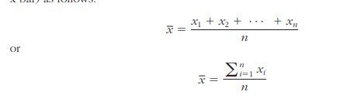
The mean has several unique characteristics. For instance, the sum of the absolute deviations above the mean are the same as the sum of the deviations below the mean, balancing the values on either side of it. That said, it does not suggest, however, that half the observations are above and the other half are below the mean. Also, the mean is unique for every data set and is meaningful and calculable for both interval- and ratio-type numeric data. One major downside is that the mean can be affected by outliers. Outliers can pull the mean toward their direction and, hence, bias the centrality representation.
Median
The median is the measure of center value in a given data set. It is the number in the middle of a given set of data that has been arranged/sorted in order of magnitude (either ascending or descending). If the number of observation is an odd number, identifying the median is very easy—just sort the observations based on their values and pick the value right in the middle. If the number of observations is an even number, then identify the two middle values, and then take the simple average of these two values. The median is meaningful and calculable for ratio, interval, and ordinal data types. Once determined, half the data points in the data are above and the other half are below the median. In contrary to the mean, the median is not affected by outliers or skewed data.
Mode
The mode is the observation that occurs most frequently. On a histogram it represents the highest bar in a bar chart, and hence, it may be considered as being the most popular option/value. The mode is most useful for data sets that contain a relatively small number of unique values. That is, it may be useless if the data have too many unique values, rendering each value having either one or a very small number representing its frequency. Although it is a useful measure (especially for nominal data), mode is not a very good representation of centrality, and therefore, it should not be used as the only measure of central tendency for a given data set.
2. List and briefly explain the dispersion measures of descriptive statistics.
Measures of dispersion (May Also Be called measures of spread or decentrality):
Measures of dispersion are the mathematical methods used to estimate or describe the degree of variation in a given variable of interest. They are a representation of the numerical spread of a given data set. To describe this dispersion, a number of statistical measures are developed; the most notable ones are range, variance, and standard deviation. One of the main reasons why the measures of dispersion/spread of data values are important is the fact that it gives us a framework within which we can judge the central tendency—gives us the indication of how well the mean represents the sample data. If the dispersion of values in the data set is large, the mean is not deemed to be a very good representation of the data. This is because a large dispersion measure indicates large differences between individual scores. Also, in research, it is often perceived as a positive sign to see a small variation within each data sample, as it may indicate homogeneity, similarity, and robustness within the collected data.
Range
The range is perhaps the simplest measure of dispersion. It is the difference between the largest and the smallest values in a given data set. So we calculate range by simply identifying the smallest value in the data set (minimum), identifying the largest value in the data set (maximum), and calculating the difference between them (range = maximum – minimum).
Variance
A more comprehensive and sophisticated measure of dispersion is the variance. It is a method used to calculate the deviation of all data points in a given data set from the mean. The larger the variance, the more the data are spread out from the mean and the more variability one can observe in the data sample. To prevent the offsetting of negative and positive differences, the variance takes into account the square of the distances from the mean. The formula for a data sample can be written as
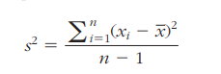
where n is the number of samples, x is the mean of the sample and xi is the ith value in the data set. The larger values of variance indicate more dispersion, whereas smaller values indicate compression in the overall data set. Because the differences are squared, larger deviations from the mean contribute significantly to the value of variance.
Standard Deviation
The standard deviation is also a measure of the spread of values within a set of data. The standard deviation is calculated by simply taking the square root of the variations. The following formula shows the calculation of standard deviation from a given sample of data points.
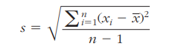
Mean Absolute Deviation
In addition to variance and standard deviation, sometimes we also use mean absolute deviation to measure dispersion in a data set. It is a simpler way to calculate the overall deviation from the mean. Specifically, it is calculated by measuring the absolute values of the differences between each data point and the mean and summing them. It provides a measure of spread without being specific about the data point being lower or higher than the mean. The following formula shows the calculation of the mean absolute deviation.
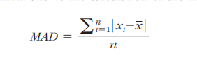
Quartiles and Interquartile Range
Quartiles help us identify spread within a subset of the data. A quartile is a quarter of the number of data points given in a data set. Quartiles are determined by first sorting the data and then splitting the sorted data into four disjoint smaller data sets. Quartiles are a useful measure of dispersion because they are much less affected by outliers or a skewness in the data set than the equivalent measures in the whole data set. Quartiles are often reported along with the median as the best choice of measure of dispersion and central tendency, respectively, when dealing with skewed and/or data with outliers. A common way of expressing quartiles is as an interquartile range, which describes the difference between the third quartile (Q3) and the first quartile (Q1), telling us about the range of the middle half of the scores in the distribution.
4. Demonstrate how a simple linear regression model can be developed using sample data.
To understand the relationship between two variables, the simplest thing that one can do is to draw a scatter plot, where the y-axis represents the values of the response variable and the x-axis represents the values of the explanatory variable. A scatter plot would show the changes in the response variable as a function of the changes in the explanatory variable.
Simple regression analysis aims to find a mathematical representation of this relationship. In reality, it tries to find the signature of a straight line passing through right between the plotted dots (representing the observation/historical data) in such a way that it minimizes the distance between the dots and the line (the predicted values on the theoretical regression line). Even though there are several methods/algorithms proposed to identify the regression line, the one that is most commonly used is called the ordinary least squares (OLS) method. The OLS method aims to minimize the sum of squared residuals and leads to a mathematical expression for the estimated value of the regression line (which are known as b parameters). For simple linear regression, the aforementioned relationship between the response variable (y) and the explanatory variable(s) (x) can be shown as a simple equation as follows:
y = b0 + b1 x
In this equation, b0 is called the intercept, and b1 is called the slope. Once OLS determines the values of these two coefficients, the simple equation can be used to forecast the values of y for given values of x. The sign and the value of b1 also reveal the direction and the strengths of relationship between the two variables. If the model is of a multiple linear regression type, then there would be more coefficients to be determined, one for each additional explanatory variable. As the following formula shows, the additional explanatory variable would be multiplied with the new bi coefficients and summed together to establish a linear additive representation of the response variable.
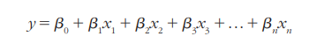
How Do We Know If the Model Is good enough?
Because of a variety of reasons, sometimes models as representations of the reality do not prove to be good. Regardless of the number of explanatory variables included, there is always a possibility of not having a good model, and therefore the linear regression model needs to be assessed for its fit (the degree at which it represents the response variable). In the simplest sense, a well-fitting regression model results in predicted values close to the observed data values. For the numerical assessment, three statistical measures are often used in evaluating the fit of a regression model. R2 (R-squared), the overall F-test, and the root mean square error (RMSE). All three of these measures are based on the sums of the square errors Different combinations of these two values provide different information about how the regression model compares to the mean model.
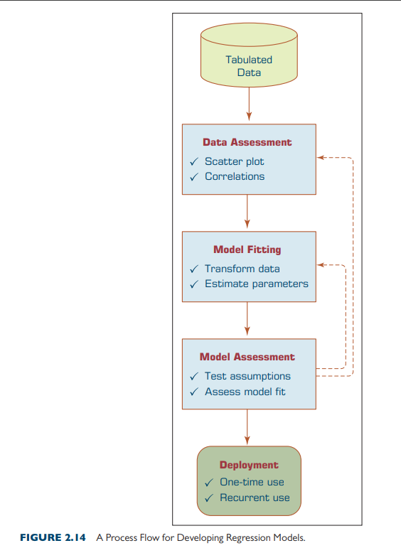

Alternative Data Warehousing Architectures At the highest level, data warehouse architecture design viewpoints can be categorized into enterprise-wide data warehouse (EDW) design and DM design (Golfarelli & Rizzi, 2009). In Figure 4.8a–e, we show some alternatives to the basic architectural design types that are neither pure EDW nor pure DM, but in between or beyond the traditional architectural structures. Notable new ones include hub-and-spoke and federated architectures. The five architectures shown in Figure 4.8a–e, are proposed by Ariyachandra and Watson (2005, 2006a,b). Previously, in an extensive study, Sen and Sinha (2005) identified 15 different data warehousing methodologies. The sources of these methodologies are classified into three broad categories: core-technology vendors, infrastructure vendors, and information-modeling companies.
• Independent data marts. This is arguably the simplest and the least costly architecture alternative. The DMs are developed to operate independent of each other to serve the needs of individual organizational units. Because of their independence, they may have inconsistent data definitions and different dimensions and measures, making it difficult to analyze data across the DMs (i.e., it is difficult, if not impossible, to get to the “one version of the truth”).
• Data mart bus architecture. This architecture is a viable alternative to the independent DMs where the individual marts are linked to each other via somekind of middleware. Because the data are linked among the individual marts, there is a better chance of maintaining data consistency across the enterprise (at least at the metadata level). Even though it allows for complex data queries across DMs, the performance of these types of analysis may not be at a satisfactory level.
• Hub-and-spoke architecture. This is perhaps the most famous data warehousing architecture today. Here the attention is focused on building a scalable and maintainable infrastructure (often developed in an iterative way, subject area by subject area) that includes a centralized data warehouse and several dependent DMs (each for an organizational unit). This architecture allows for easy customization of user interfaces and reports. On the negative side, this architecture lacks the holistic enterprise view and may lead to data redundancy and data latency.
• Centralized data warehouse. The centralized data warehouse architecture is similar to the hub-and-spoke architecture except that there are no dependent DMs; instead, there is a gigantic EDW that serves the needs of all organizational units. This centralized approach provides users with access to all data in the data warehouse instead of limiting them to DMs. In addition, it reduces the amount of data the technical team has to transfer or change, therefore simplifying data management and administration. If designed and implemented properly, this architecture provides a timely and holistic view of the enterprise to whoever, whenever, and wherever they may be within the organization.
• Federated data warehouse. The federated approach is a concession to the natural forces that undermine the best plans for developing a perfect system. It uses all possible means to integrate analytical resources from multiple sources to meet changing needs or business conditions. Essentially, the federated approach involves integrating disparate systems. In a federated architecture, existing decision support structures are left in place, and data are accessed from those sources as needed. The federated approach is supported by middleware vendors that propose distributed query and join capabilities. These eXtensible Markup Language (XML)–based tools offer users a global view of distributed data sources, including data warehouses, DMs, Web sites, documents, and operational systems. When users choose query objects from this view and press the submit button, the tool automatically queries the distributed sources, joins the results, and presents them to the user. Because of performance and data quality issues, most experts agree that federated approaches work well to supplement data warehouses, not replace them (see Eckerson, 2005)
